Project Design Phase-II
Technology Stack (Architecture & Stack)

Date | 18 February 2026
Team ID | LTVIP2026TMIDS53672
Project Name | Exploratory Analysis of Rain Fall Data in India for Agriculture
Maximum Marks | 4 Marks

Technical Architecture:

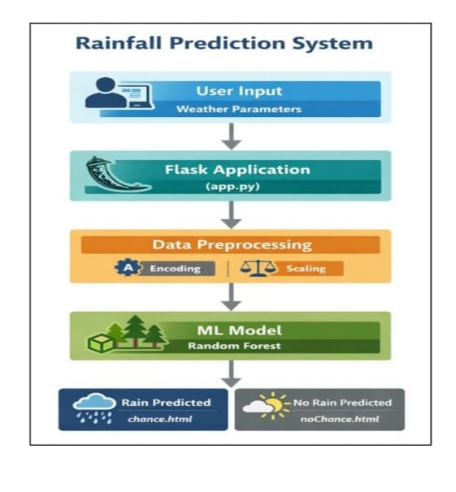

Table-1 : Components & Technologies:
S.No | Component | Description | Technology
 | User Interface |  | HTML, CSS, JavaScript
  Allows users to enter weather data and view
  rainfall prediction results.
 | Application Logic | Processes user requests and controls application flow. | Python, Flask
 |  | Encodes categorical values and scales numerical input data. | Pandas, NumPy, Scikit-learn
  Data Preprocessing
 | Machine Learning Model | Predicts whether there is a chance of rain or no rain. | XGBoost
 | Model Storage | Stores the trained machine learning model for prediction. | Pickel(.pkl)
 | File Storage | Stores dataset and trained model files locally. | Local File System
 |  | Provides real-time weather data for prediction | Weather API
  External API
 | Infrastructure | Environment where the application is deployed. | Local Server

Table-2: Application Characteristics:
S.No | Characteristics | Description | Technology
 | Open-Source Frameworks | Frameworks used to develop the application. | Flask, Scikit-learn, XGBoost
 | Security Implementations | Ensures secure access and safe handling of user inputs. | Input validation
 | Scalable Architecture | Supports future expansion and enhancement. | Three-tier architecture
 | Availability | Ensures the application is accessible when required. | Local deployment
 | Performance | Optimized to provide fast rainfall prediction results. | Efficient ML model

